TC-DISP-018
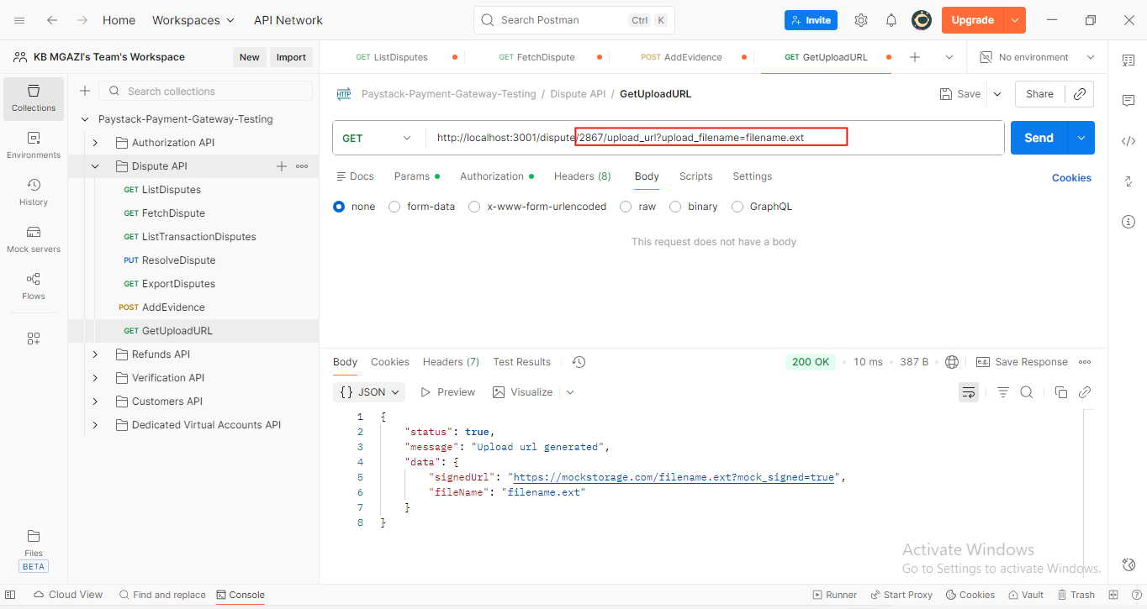
Response:
{
"status": true,
"message": "Upload url generated",
"data": {
"signedUrl": "https://mockstorage.com/filename.ext?mock_signed=true",
"fileName": "filename.ext"
}
}

